**Commodore C64 WiFi-Modem PET Adapter Rev. 0  
Testing**

# Test Setup

The Test was conducted on a CBM8032 with a German character set, a C64 WiFi-Modem (like mentioned in Document 175-6-01-**), a Cassette Port dongle Rev. 1 and a C64 WiFi-Modem Adapter Rev. 0. The software PETTERM0-5-0 was stored on an SD-card in the SD2PET future.

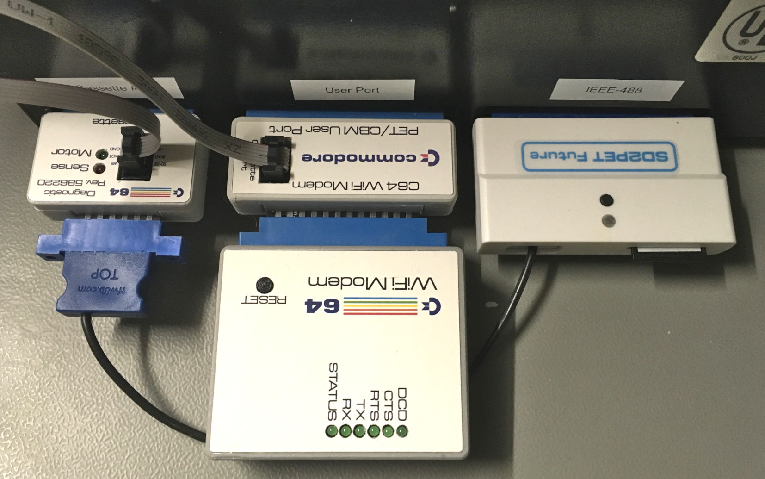

Figure 1: Test Setup

The baud rate of the modem was set to 1200baud (this configuration was done and stored with the software CSMG2017 running on a C64).

# Test Execution

Several BBSes have been called. The WiFi-Modem has been fully operational at all time, the information transfer was correct.

# Conclusion

**The WiFi-Modem Adapter is fully functional.**

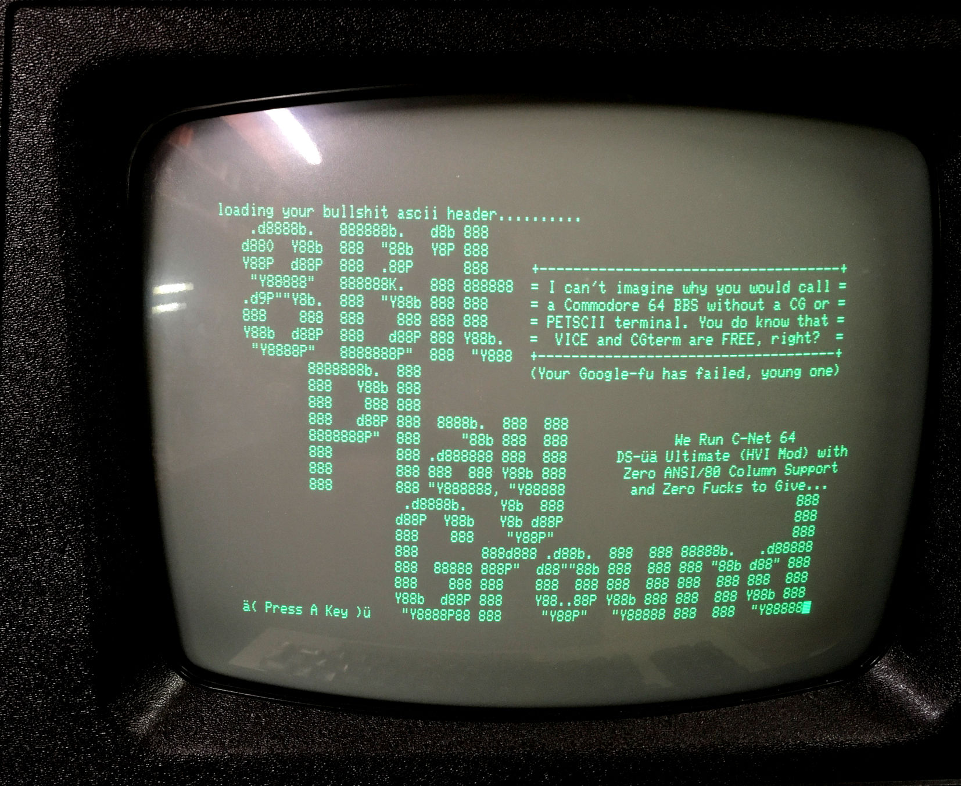

Figure 2: CBM8032 connected to the BBS 8Bit Playground